**PRACTICAL 8**

**AIM:**

Create Decentralized application “Voting” using Ethereum. Set up development environment using Truffle framework and Ganache, Metamask of chrome extension.

**PREREQUISITES:**

* Nodejs
* Ganache
* Truffle
* Metamask Extension

**STEPS TO MAKE DECENTRALIZED ELECTION SYTEM:**

1. First make an empty directory and then run below command in cmd to download and unbox pet-shop example.
   1. truffle unbox pet-shop

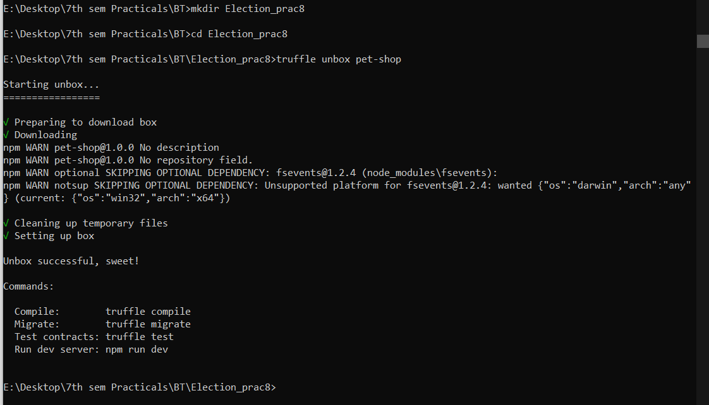

1. now you can see the file structure like below image in that empty directory.

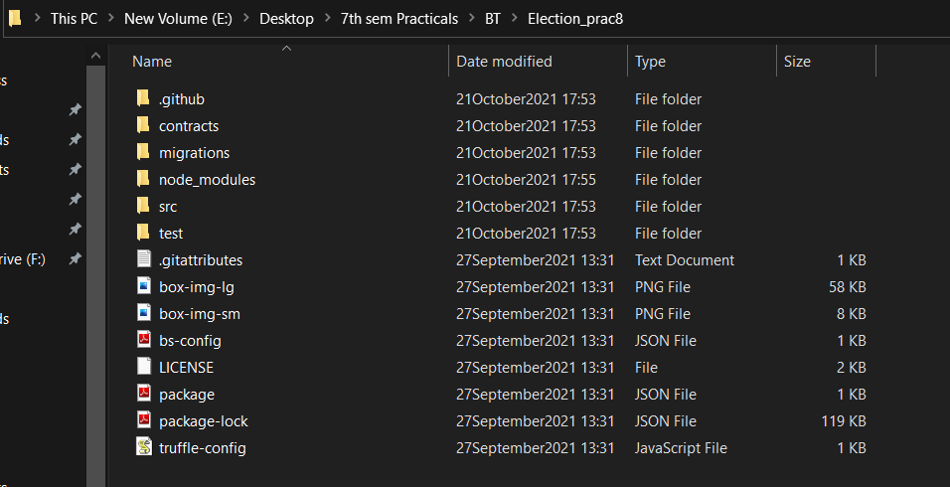

1. now go to contracts folder and you can see one migrations.sol file so you have to make same file as migrations.sol and name as **“Election.sol”** and then write below code into that file and save it.

**Election.sol**

pragma solidity 0.5.16;

contract Election {

// Model a Candidate

struct Candidate {

uint id;

string name;

uint voteCount;

}

// Store accounts that have voted

mapping(address => bool) public voters;

// Store Candidates

// Fetch Candidate

mapping(uint => Candidate) public candidates;

// Store Candidates Count

uint public candidatesCount;

// voted event

event votedEvent (

uint indexed _candidateId

);

constructor () public {

addCandidate("Candidate 1");

addCandidate("Candidate 2");

}

function addCandidate (string memory _name) private {

candidatesCount ++;

candidates[candidatesCount] = Candidate(candidatesCount, _name, 0);

}

function vote (uint _candidateId) public {

// require that they haven't voted before

require(!voters[msg.sender]);

// require a valid candidate

require(_candidateId > 0 && _candidateId <= candidatesCount);

// record that voter has voted

voters[msg.sender] = true;

// update candidate vote Count

candidates[_candidateId].voteCount ++;

// trigger voted event

emit votedEvent(_candidateId);

}

}

1. now go to migrations folder there you can see the file named as “1_initial_migration.js” same as above step you have to create a file named as **“2_deploy_contracts.js”** and add below code into that file and save it.

**Note : the sol file name will be considered in this file so as we have created Election.sol so that the file will be called in this file.**

**2_deploy_contracts.js**

var Election = artifacts.require("./Election.sol");

module.exports = function(deployer) {

deployer.deploy(Election);

};

1. so we are ready to create our frontend part of this application.
2. Go to src folder and see the index.html and you can create your own frontend but for reference the code of the frontend is below.

**Index.html**

<!DOCTYPE html>

<html lang="en">

<head>

<meta charset="utf-8">

<meta http-equiv="X-UA-Compatible" content="IE=edge">

<meta name="viewport" content="width=device-width, initial-scale=1">

<!-- The above 3 meta tags *must* come first in the head; any other head content must come *after* these tags -->

<title>Election Results</title>

<!-- Bootstrap -->

<link href="css/bootstrap.min.css" rel="stylesheet">

<!-- HTML5 shim and Respond.js for IE8 support of HTML5 elements and media queries -->

<!-- WARNING: Respond.js doesn't work if you view the page via file:// -->

<!--[if lt IE 9]>

<script src="https://oss.maxcdn.com/html5shiv/3.7.3/html5shiv.min.js"></script>

<script src="https://oss.maxcdn.com/respond/1.4.2/respond.min.js"></script>

<![endif]-->

</head>

<body>

<div class="container" style="width: 650px;">

<div class="row">

<div class="col-lg-12">

<h1 class="text-center">Election Results</h1>

<hr/>

<br/>

<div id="loader">

<p class="text-center">Loading...</p>

</div>

<div id="content" style="display: none;">

<table class="table">

<thead>

<tr>

<th scope="col">#</th>

<th scope="col">Name</th>

<th scope="col">Votes</th>

</tr>

</thead>

<tbody id="candidatesResults">

</tbody>

</table>

<hr/>

<form onSubmit="App.castVote(); return false;">

<div class="form-group">

<label for="candidatesSelect">Select Candidate</label>

<select class="form-control" id="candidatesSelect">

</select>

</div>

<button type="submit" class="btn btn-primary">Vote</button>

<hr />

</form>

<p id="accountAddress" class="text-center"></p>

</div>

</div>

</div>

</div>

<!-- jQuery (necessary for Bootstrap's JavaScript plugins) -->

<script src="https://ajax.googleapis.com/ajax/libs/jquery/1.12.4/jquery.min.js"></script>

<!-- Include all compiled plugins (below), or include individual files as needed -->

<script src="js/bootstrap.min.js"></script>

<script src="js/web3.min.js"></script>

<script src="js/truffle-contract.js"></script>

<script src="js/app.js"></script>

</body>

</html>

1. Now to connect metamask with our own created application we have to do some changes into the app.js file so go to src folder and then go to js folder and open js file then copy below code and paste it there.

**app.js**

App = {

web3Provider: null,

contracts: {},

account: '0x0',

hasVoted: false,

init: function() {

return App.initWeb3();

},

initWeb3: function() {

// TODO: refactor conditional

if (typeof web3 !== 'undefined') {

// If a web3 instance is already provided by Meta Mask.

App.web3Provider = web3.currentProvider;

web3 = new Web3(web3.currentProvider);

} else {

// Specify default instance if no web3 instance provided

App.web3Provider = new Web3.providers.HttpProvider('http://127.0.0.1:7545');

web3 = new Web3(App.web3Provider);

}

return App.initContract();

},

initContract: function() {

$.getJSON("Election.json", function(election) {

// Instantiate a new truffle contract from the artifact

App.contracts.Election = TruffleContract(election);

// Connect provider to interact with contract

App.contracts.Election.setProvider(App.web3Provider);

App.listenForEvents();

return App.render();

});

},

// Listen for events emitted from the contract

listenForEvents: function() {

App.contracts.Election.deployed().then(function(instance) {

// Restart Chrome if you are unable to receive this event

// This is a known issue with Metamask

// https://github.com/MetaMask/metamask-extension/issues/2393

instance.votedEvent({}, {

fromBlock: 0,

toBlock: 'latest'

}).watch(function(error, event) {

console.log("event triggered", event)

// Reload when a new vote is recorded

App.render();

});

});

},

render: function() {

var electionInstance;

var loader = $("#loader");

var content = $("#content");

loader.show();

content.hide();

// Load account data

web3.eth.getCoinbase(function(err, account) {

if (err === null) {

App.account = account;

$("#accountAddress").html("Your Account: " + account);

}

});

// Load contract data

App.contracts.Election.deployed().then(function(instance) {

electionInstance = instance;

return electionInstance.candidatesCount();

}).then(function(candidatesCount) {

var candidatesResults = $("#candidatesResults");

candidatesResults.empty();

var candidatesSelect = $('#candidatesSelect');

candidatesSelect.empty();

for (var i = 1; i <= candidatesCount; i++) {

electionInstance.candidates(i).then(function(candidate) {

var id = candidate[0];

var name = candidate[1];

var voteCount = candidate[2];

// Render candidate Result

var candidateTemplate = "<tr><th>" + id + "</th><td>" + name + "</td><td>" + voteCount + "</td></tr>"

candidatesResults.append(candidateTemplate);

// Render candidate ballot option

var candidateOption = "<option value='" + id + "' >" + name + "</ option>"

candidatesSelect.append(candidateOption);

});

}

return electionInstance.voters(App.account);

}).then(function(hasVoted) {

// Do not allow a user to vote

if(hasVoted) {

$('form').hide();

}

loader.hide();

content.show();

}).catch(function(error) {

console.warn(error);

});

},

castVote: function() {

var candidateId = $('#candidatesSelect').val();

App.contracts.Election.deployed().then(function(instance) {

return instance.vote(candidateId, { from: App.account });

}).then(function(result) {

// Wait for votes to update

$("#content").hide();

$("#loader").show();

}).catch(function(err) {

console.error(err);

});

}

};

$(function() {

$(window).load(function() {

App.init();

});

});

1. So we are almost ready to launch the frontend, but lets first make one last file into the test folder named as **“election.js”** and write below code into that file.

**election.js**

var Election = artifacts.require("./Election.sol");

contract("Election", function(accounts) {

var electionInstance;

it("initializes with two candidates", function() {

return Election.deployed().then(function(instance) {

return instance.candidatesCount();

}).then(function(count) {

assert.equal(count, 2);

});

});

it("it initializes the candidates with the correct values", function() {

return Election.deployed().then(function(instance) {

electionInstance = instance;

return electionInstance.candidates(1);

}).then(function(candidate) {

assert.equal(candidate[0], 1, "contains the correct id");

assert.equal(candidate[1], "Candidate 1", "contains the correct name");

assert.equal(candidate[2], 0, "contains the correct votes count");

return electionInstance.candidates(2);

}).then(function(candidate) {

assert.equal(candidate[0], 2, "contains the correct id");

assert.equal(candidate[1], "Candidate 2", "contains the correct name");

assert.equal(candidate[2], 0, "contains the correct votes count");

});

});

it("allows a voter to cast a vote", function() {

return Election.deployed().then(function(instance) {

electionInstance = instance;

candidateId = 1;

return electionInstance.vote(candidateId, { from: accounts[0] });

}).then(function(receipt) {

assert.equal(receipt.logs.length, 1, "an event was triggered");

assert.equal(receipt.logs[0].event, "votedEvent", "the event type is correct");

assert.equal(receipt.logs[0].args._candidateId.toNumber(), candidateId, "the candidate id is correct");

return electionInstance.voters(accounts[0]);

}).then(function(voted) {

assert(voted, "the voter was marked as voted");

return electionInstance.candidates(candidateId);

}).then(function(candidate) {

var voteCount = candidate[2];

assert.equal(voteCount, 1, "increments the candidate's vote count");

})

});

it("throws an exception for invalid candiates", function() {

return Election.deployed().then(function(instance) {

electionInstance = instance;

return electionInstance.vote(99, { from: accounts[1] })

}).then(assert.fail).catch(function(error) {

assert(error.message.indexOf('revert') >= 0, "error message must contain revert");

return electionInstance.candidates(1);

}).then(function(candidate1) {

var voteCount = candidate1[2];

assert.equal(voteCount, 1, "candidate 1 did not receive any votes");

return electionInstance.candidates(2);

}).then(function(candidate2) {

var voteCount = candidate2[2];

assert.equal(voteCount, 0, "candidate 2 did not receive any votes");

});

});

it("throws an exception for double voting", function() {

return Election.deployed().then(function(instance) {

electionInstance = instance;

candidateId = 2;

electionInstance.vote(candidateId, { from: accounts[1] });

return electionInstance.candidates(candidateId);

}).then(function(candidate) {

var voteCount = candidate[2];

assert.equal(voteCount, 1, "accepts first vote");

// Try to vote again

return electionInstance.vote(candidateId, { from: accounts[1] });

}).then(assert.fail).catch(function(error) {

assert(error.message.indexOf('revert') >= 0, "error message must contain revert");

return electionInstance.candidates(1);

}).then(function(candidate1) {

var voteCount = candidate1[2];

assert.equal(voteCount, 1, "candidate 1 did not receive any votes");

return electionInstance.candidates(2);

}).then(function(candidate2) {

var voteCount = candidate2[2];

assert.equal(voteCount, 1, "candidate 2 did not receive any votes");

});

});

});

1. Our part is almost done so open ganache you will get 2 options like below image.

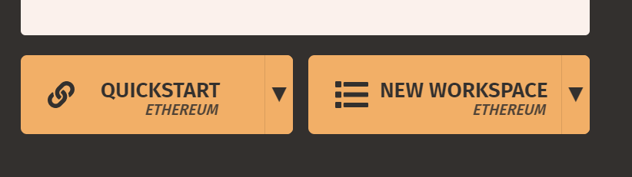

1. Choose new workspace and name that you want. Then click on add project and choose **“truffle-config.js”** and then click on save workspace.

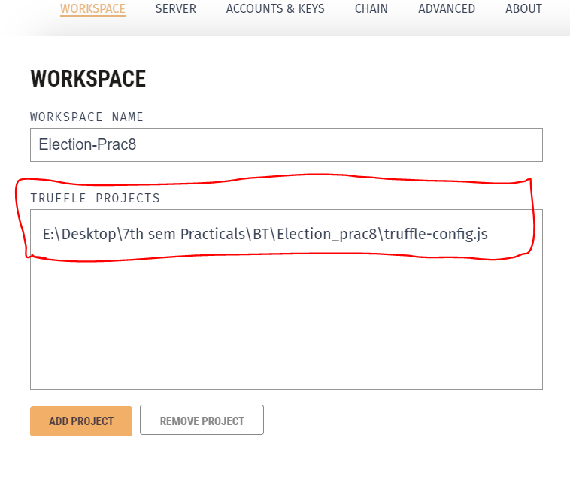

1. Now open cmd and run below command in the project folder.
   1. truffle migrate

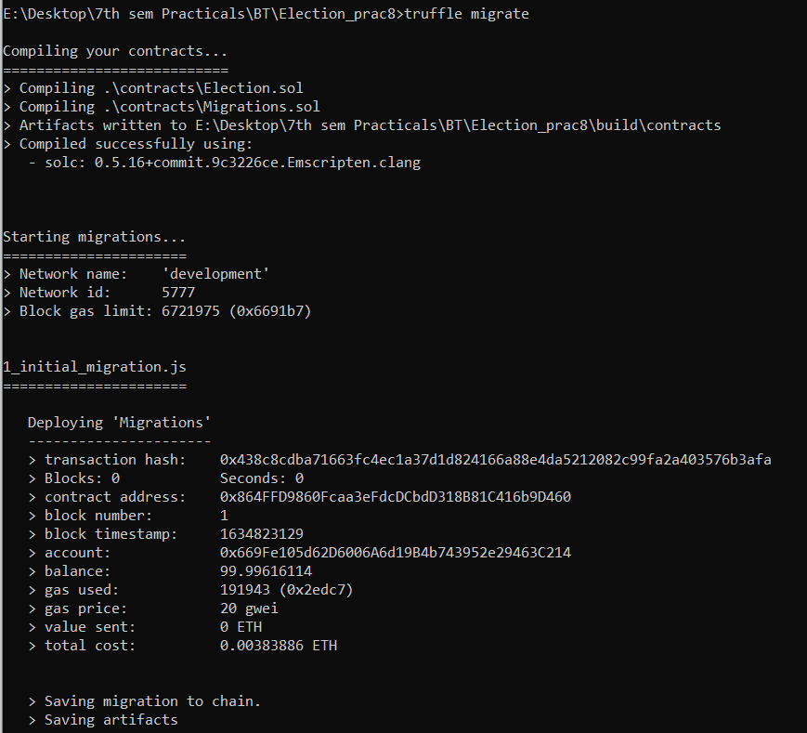

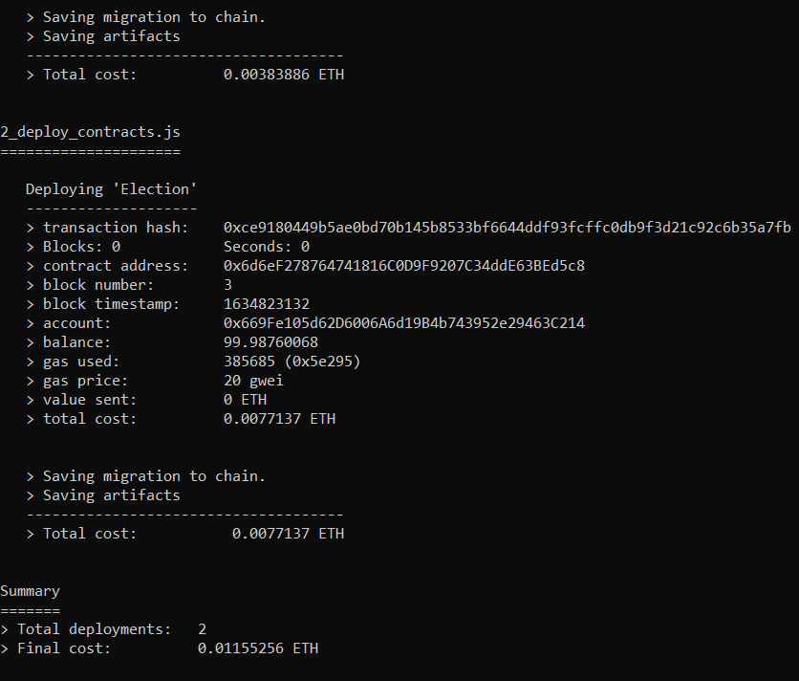

1. you can see the transaction into the transactions panel of ganache and you can also see the contract that you have deployed just some seconds ago.

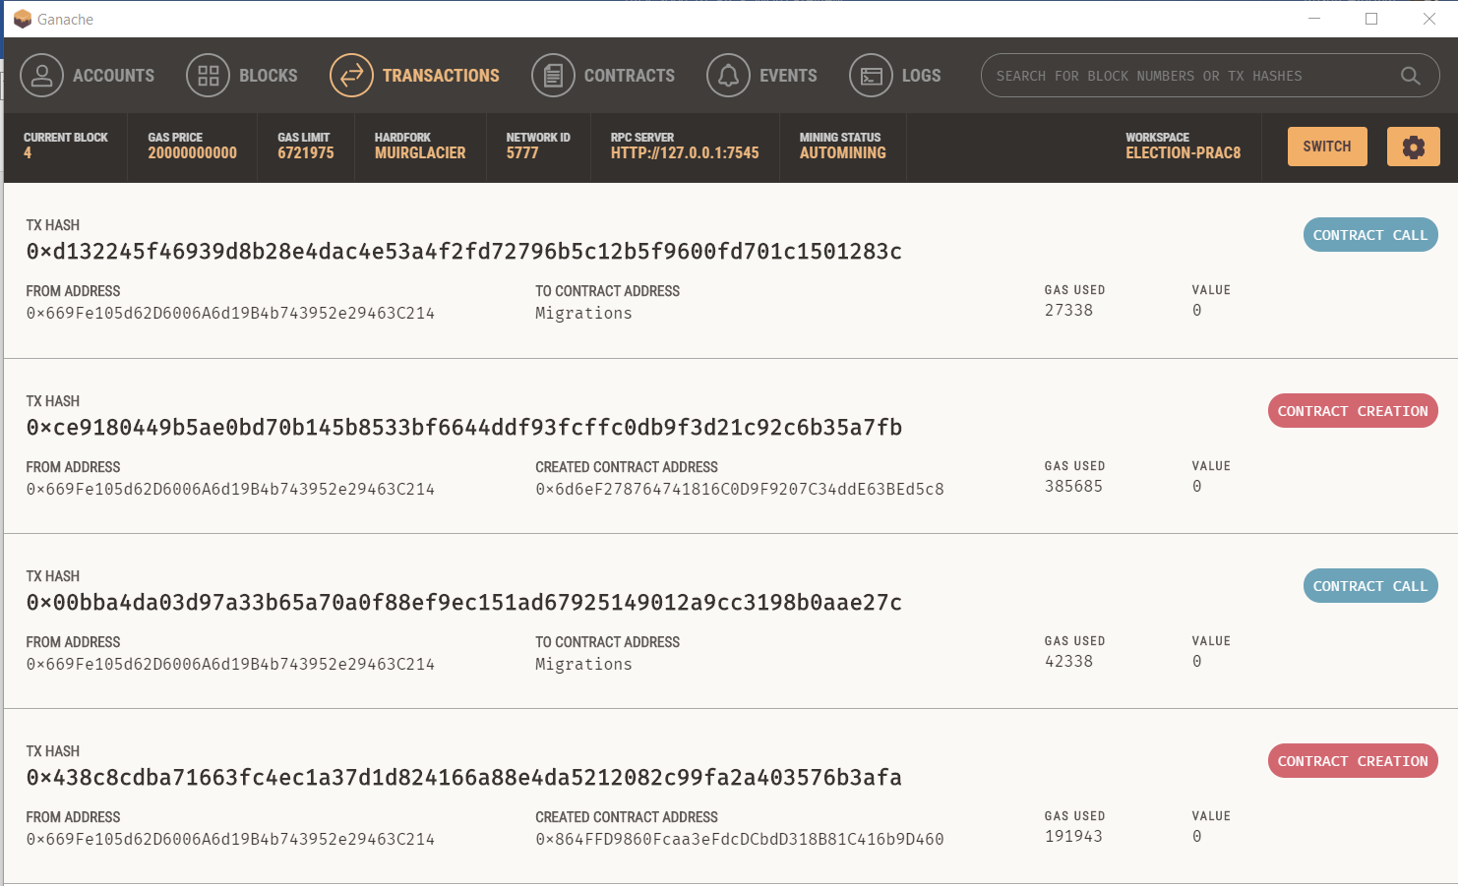

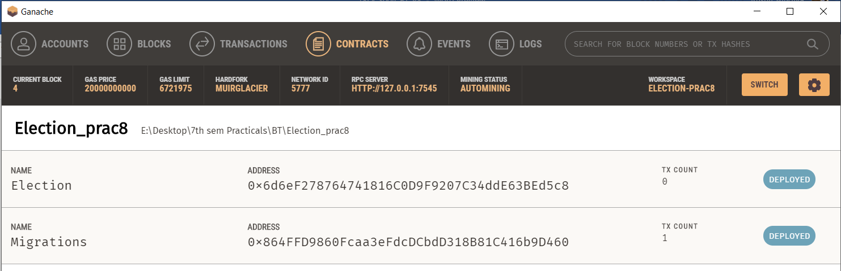

1. run below command to see the frontend part into your localhost browser.
   1. npm run dev

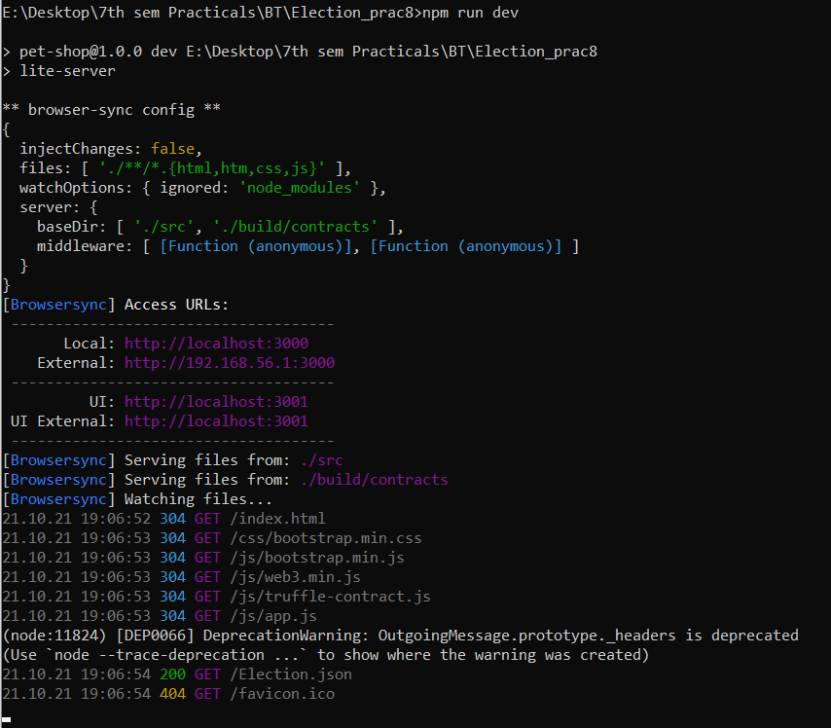

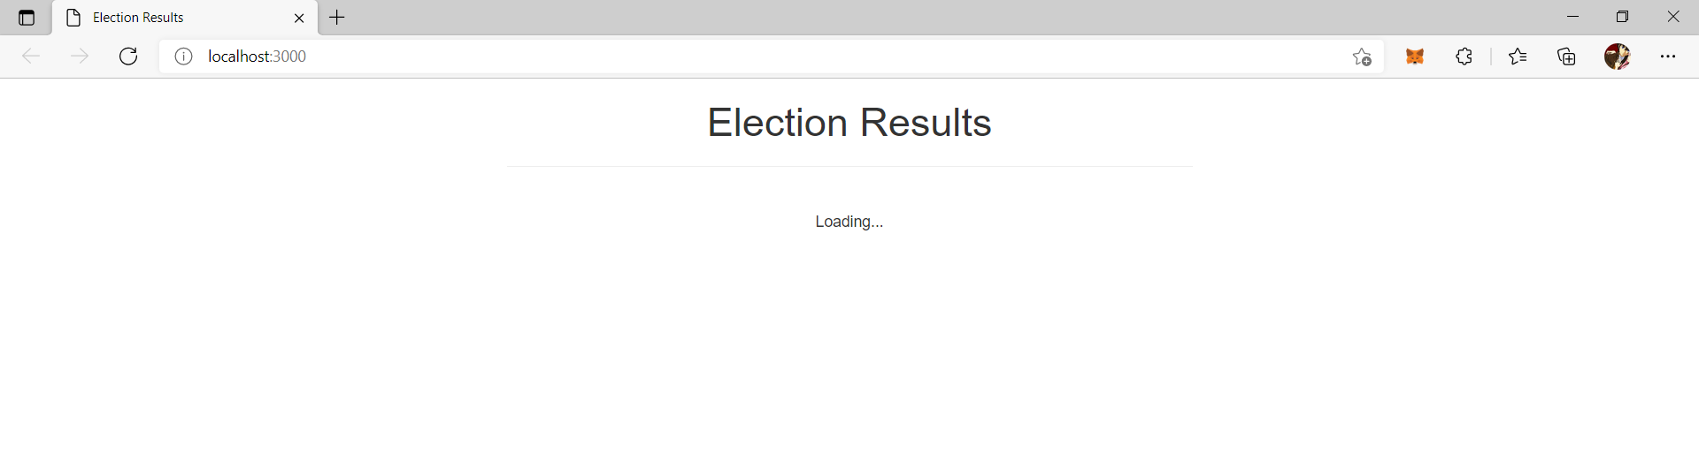

1. Now we have to connect the metamask with our application. Open metamask from extension panel in your browser then go to custom rpc in the network section.

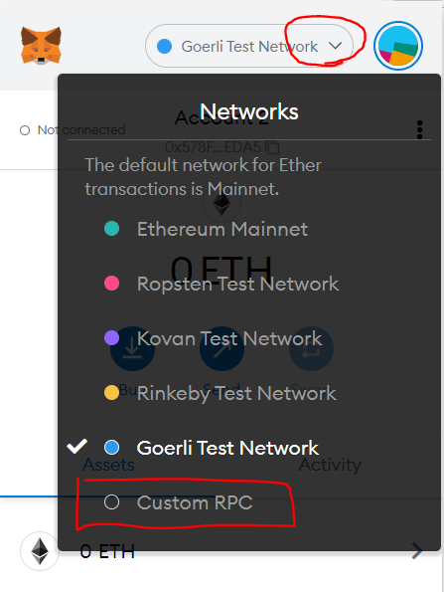

1. Now fill the details from below image and click on save button.

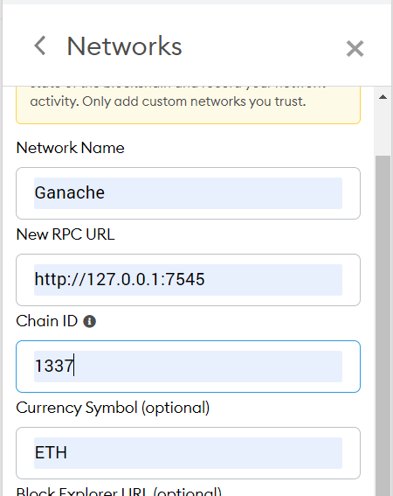

1. Go to account section and the click on import account.

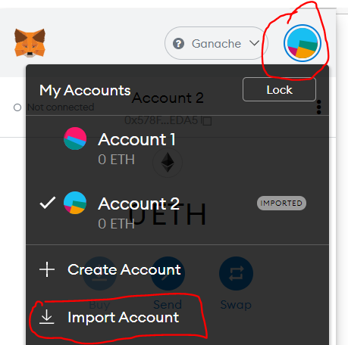

1. you can get the private key from the ganache account panel you can see the steps in below images. Then copy the private key and paste it into the metamask and click on import.

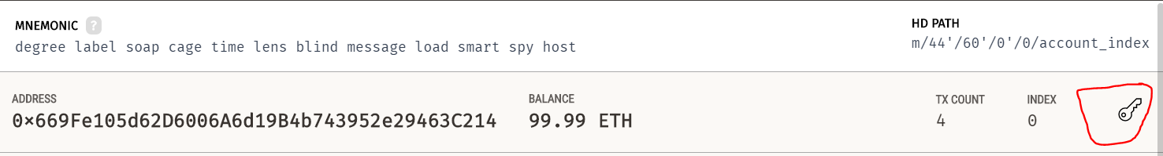

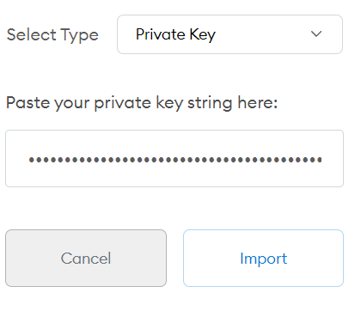

1. click on **“not connected”** to connect to the localhost.

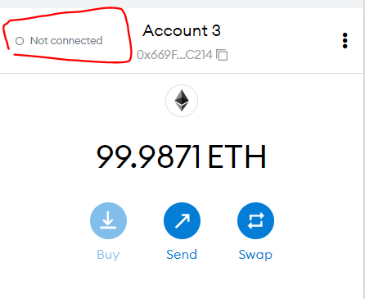

1. if you get an error like below image then follow step 20.

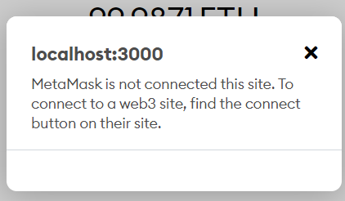

1. click on the three dots and the click on connected sites. Then click on manually connect to the current site. Select account and click on next and then click on connect.

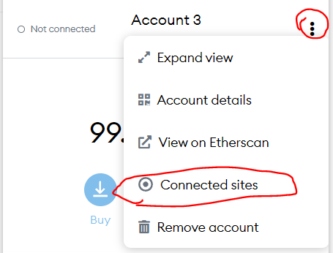 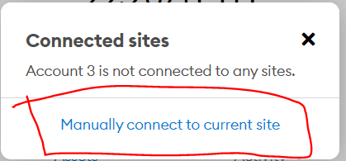

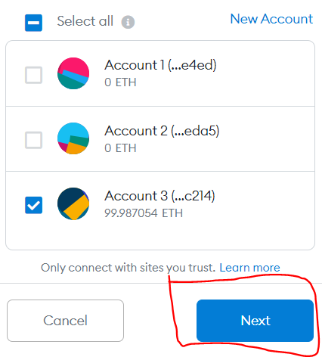 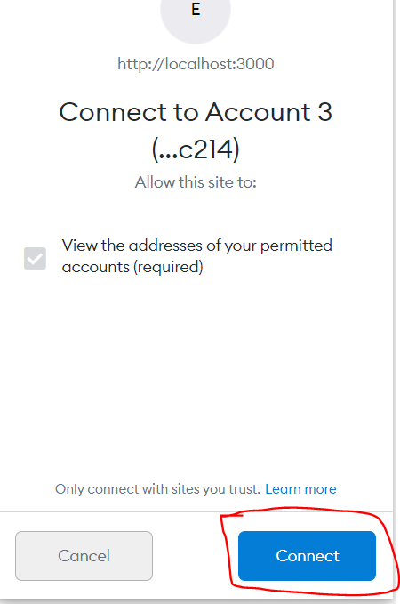

1. after connecting to the metamask you can see the frontend like below image.

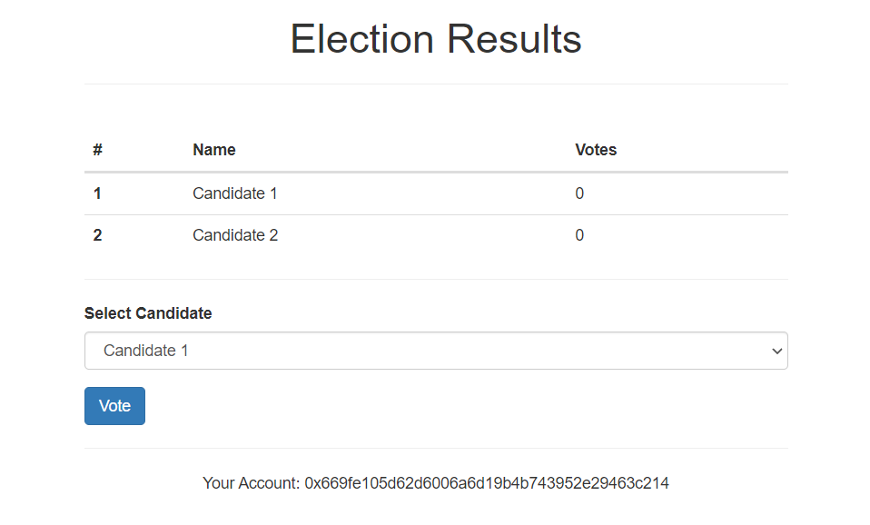

1. you can vote any candidate by choosing from drop down menu and by clicking on vote button. You can also change account and then you can vote from second account.

**OUTPUT:**

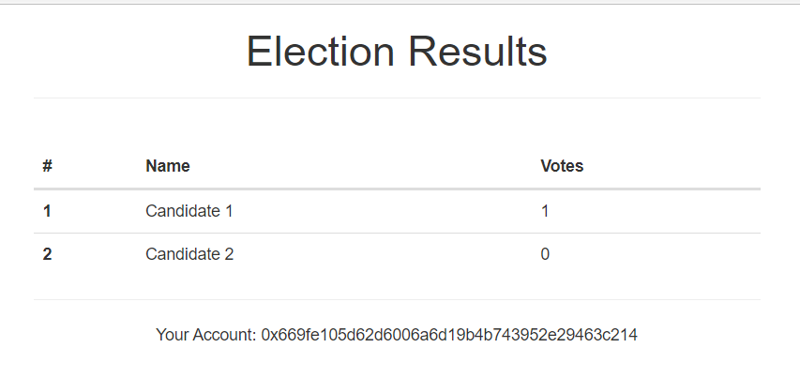

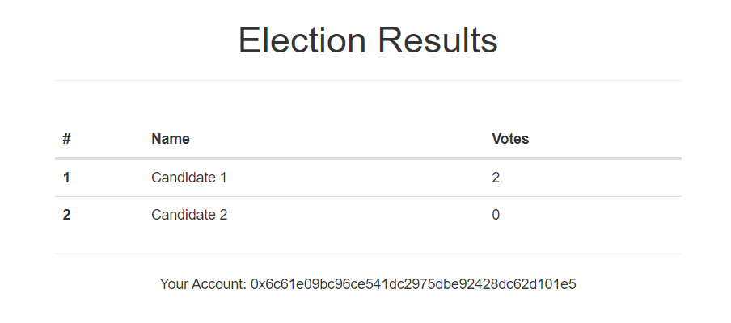

**CONCLUSION:**

In this practical, we thoroughly understood the concept of ganache, Truffle and implemented basic election system using it.